

EUC Workload Scenario v1.3



Contents
Contents 2
Introduction 3
The Scenarios 3
Office Applications 4
Workload Layout 5
Share Data Zip File 6
A Breakdown of Each Scenario 9
EUC Main 9
Citrix Login 10
Initiation 10
Check App 10
Close App 10
Browser_Base 11
Outlook – New Email 11
Email – Reply 11
Browser – Bouncing 11
Browser – Cyber 11
Browser – Folio 11
Browser – Video1 11
Browser – Video 2 11
MS Excel 12
MS PowerPoint 12
MS Word 12
PDF 12
Logoff User 12
Prerequisites 13

Introduction

Automai Loader is an automated testing platform that uses defined scenarios that mimic a user’s behaviour to simulate any number of user sessions. This allows administrators to confirm if a system’s capacity can perform with the designed number of users. The data collected can aid in identifying performance bottlenecks that may be alleviated to optimize the system and increase capacity further.

Additionally, performing a comparative test before rolling out changes to the system can identify any effects that software updates or system configurations change will have on user experience. Comparing a Load Test on an updated image and compare it to the previous test can identify if any additional infrastructure is required for the update.

Users interact with their applications and desktops differently, depending on their job responsibilities. These are usually broken into three categories, Task, Knowledge and Power workers. Each category will put a different load on a system, with Task workers being the lightest load, Knowledge workers having a medium load and Power workers having the heaviest load.

Automai has created a set of scripts or scenarios that can be customized to simulate any level of user workload; this document describes how they were built and how to use them. The workload scripts are provided and should run without any further customization.

The scripts are preconfigured to work with Citrix Virtual Apps & Desktops, the ability to use other platforms such as Microsoft Windows Virtual Desktop or VMware Horizon View, create a scenario to log on and log off the system and inject that from the EUC Main Workload.

AIChannel is an Autmai technology that allows an agent to run inside the worker machines, this agent can accept commands directly without graphical interaction. This adds an enhancement to Automai’s already vast set of abilities. This technology requires a network share that is reachable from both the workers and the bot manager.

The Scenarios

The EUC Main Worker scenario is a framework designed to be easily modified for your specific needs using variables in Director.

The preconfigured solution will run MS Office applications, Word, Excel, Powerpoint and Outlook, opening up a PDF file and several web pages. As such, these applications should be installed on the system being tested. If you have different applications for these operations, you can add additional scenarios to support these.

A content file is also included and expected to be available on the network for the main workload to access. These are included in the Content.zip file. This file is included with the EUC Workload scripts and must be placed in a location accessible by all test accounts. (Read permissions are required). Put the path to the file in the Variable “Content_Zip” in the Director test run configuration

Office Applications

Office applications and standard practice in today’s modern workplace. The latest version of Microsoft Office is the Microsoft 365 Apps; this requires an online Office 365 license for you to use this version. There are also special considerations on how a desktop should be configured for activation to be seamless and not bring up any prompts or issues.

To test these applications, Microsoft released some information on how to place Microsoft 365 Apps into a “test” mode. This is fully supported in the default workloads with a pre-staged PST file. Alternatively, you can license your synthetic users and configure your environment for seamless office activation and account setup.

A script is provided in the Share_Data.zip file, which you can run on each workload machine as a startup script if you wish to place M365 Apps into test mode. The license period for test mode is five days, so consider your strategy for handling this. We recommend that your servers are not activated with the test license; therefore, each time they reboot, they get a 5-day grace license.

The script in question is called “Place_Office_In_Test_Mode.bat”.

A variable that must be set in the test plan, “” which will escape the office “sign in” screen when an office application is launched.

Workload Layout
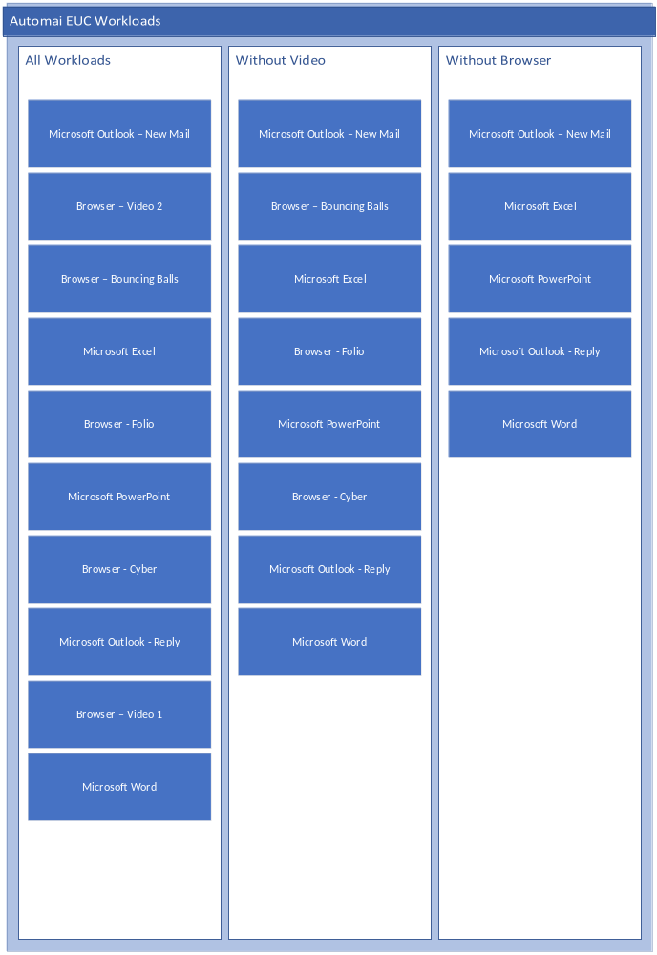

Share Data Zip File
The Share_Data.zip file is required to be deployed in a shared location that can be reached by both the workers and the Automai Bot Manager. The below diagram depicts the folder structure once this zip file has been deployed. The variables that are required to be amended within the workload are also displayed.
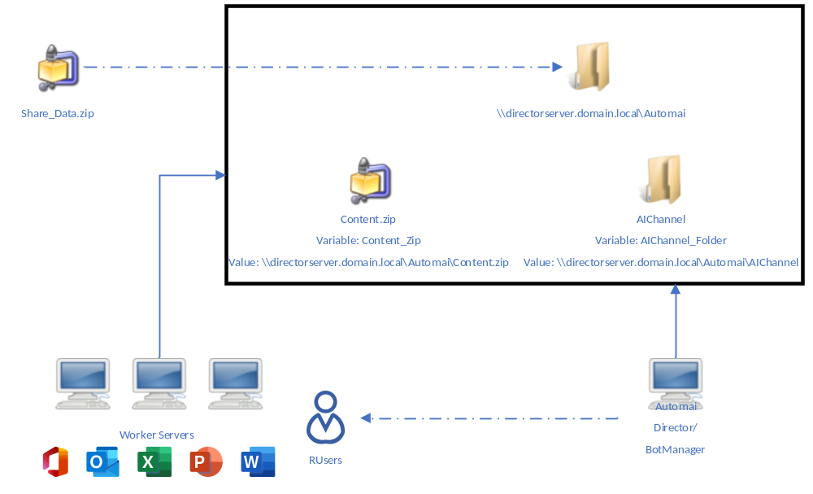
Global Variables
The table below lists all the global variables that are available in Director when creating a Test Plan for the EUC Workloads; there is an explanation presented for each variable.

Variable Name | Default Value | Explanation | Environment Specific
Logoff_On_Failure | 1 | If a failure occurs during the workload should the logoff scenario be run - 1 for yes and 0 for no
Logoff_On_Complete | 1 | Once the workload has completed, should the user automatically logoff - 1 for yes and 0 for no
CloseBrowser_OnEnd | 1 | When a browser workload has run should it close the browser - 1 for yes and 0 for no
CloseExcel_OnEnd | 1 | When the excel workload has run should it close excel - 1 for yes and 0 for no
CloseOutlook_OnEnd | 1 | When the outlook workload has run should it close Outlook - 1 for yes and 0 for no
ClosePowerPoint_OnEnd | 1 | When the powerpoint workload has run should it close powerpoint - 1 for yes and 0 for no
CloseWord_OnEnd | 1 | When the word workload has run should it close word - 1 for yes and 0 for no
RunExcel | 1 | Choose to run Excel workload(s) or not - 1 for yes and 0 for no
RunOutlook | 1 | Choose to run Outlook workload(s) or not - 1 for yes and 0 for no
RunPowerPoint | 1 | Choose to run PowerPoint workload(s) or not - 1 for yes and 0 for no
RunWord | 1 | Choose to run Word workload(s) or not - 1 for yes and 0 for no
RunPDF | 1 | Choose to run the sample PDF workload(s) or not - 1 for yes and 0 for no
RunBrowser | 1 | Choose to run Browser workload(s) or not - 1 for yes and 0 for no
Reuse_Browser_Tab | 0 | Choose to reuse the same browser tab for all workloads or open additional tabs - 1 for yes and 0 for no
Browser_Choice | Chrome | Choose the browser to work with - Chrome, FireFox, IE or MSEdge
Browser_Video | 1 | Choose to include Video in the browser workloads or not - 1 for yes and 0 for no
Chrome_Location | C:\Program Files (x86)\Google\Chrome\Application\Chrome.exe | The executable location for Chrome | Yes
Excel_Location | C:\Program Files\Microsoft\Office\root\Office16\excel.exe | The executable location for Excel | Yes
FireFox_Location | C:\Program Files\Mozilla Firefox\firefox.exe | The executable location for FireFox | Yes
IE_Location | C:\Program Files\internet explorer\iexplore.exe | The executable location for Internet Explorer | Yes
MSEdge_Location | C:\Program Files (x86)\Microsoft\Edge\Application\msedge.exe | The executable location for Microsoft Edge | Yes
Outlook_Location | C:\Program Files\Microsoft\Office\root\Office16\outlook.exe | The executable location for Outlook | Yes
PowerPoint_Location | C:\Program Files\Microsoft\Office\root\Office16\powerpnt.exe | The executable location for PowerPoint | Yes
Word_Location | C:\Program Files\Microsoft\Office\root\Office16\winword.exe | The executable location for Microsoft Word | Yes
Environment_Type | Citrix | Virtual environment being connected to - only option available at the time of writing is Citrix | Yes
Domain | domain.local | The domain of your virtual users connecting into your virtual environment | Yes
Citrix_URL | https://storefront.domain.local/citrix/storeweb | The URL for the Citrix Storefront connection | Yes
Citrix_Desktop_Name | Automai | The name of the Citrix Desktop to be launched | Yes
Outlook_Mode | PST | The mode Outlook will be placed in - PST (Local PST supplied by Automai), O365 (Configured for Outlook to detect the users account)
Office_In_Test_Mode | 1 | If office is using a test key (5 Day trial testing license) then set this variable to 1 | Yes
Content_Zip | \\computername.domain.local\Share\Automai\content.zip | The location of the Automai content zip file that the workloads rely on | Yes
AIChannel_Folder | \\computername.domain.local\Share\Automai\AIChannel | The location that AI Channel is located, all working files for AI Channel will be stored in this directory. Must be reachable from the workers and botmanager. | Yes

Variables that are marked as “Environment Specific” should be updated to align with the testing environment.

A Breakdown of Each Scenario

This section will breakdown the basic function of each scenario in the EUC workloads.

EUC Main

The EUC Main scenario is the over-arching Parent scenario. It calls the other scenarios.

- Citrix Login – Establish a connection to a Citrix Published Desktop.

- Initiation – This sets up the user profile for the test. The scenario, as provided, performs two functions:

  - Extracts the Content.zip to the user’s profile folder.
  - Runs PowerShell commands to configure all applications to run with the testing scenarios
- MS Outlook – New – Launches Outlook and creates a new mail
- Browser_Base – Video 2 – Launches your browser and plays the Video2 workload
- Browser_Base – Bouncing – Launches your browser and opens a graphical bouncing balls site
- PDF – Opens a PDF directly to be opened within your default PDF viewer
- MS Excel – Opens a template sales worksheet in Excel
- Browser_Base – Folio – Launches your browser and navigates through a template Folio site
- MS PowerPoint – Opens powerpoint and creates a new presentation
- Browser_Base – Cyber – Launches your browser and navigates around a template Cyber site
- PDF – Opens a PDF directly to be opened within your default PDF viewer
- MS Outlook – Reply – Launches outlook and replies to an existing email
- Browser_Base – Video 1 – Launches your browser and plays the Video1 workload
- MS Word – Launches work and creates a new document

Citrix Login
The Citrix Logon.XML scenario uses the built-in function to logon to a Citrix Virtual desktop. Parameters are passed from the Director into this script.

- Citrix Login
  - Storefront site URL - %Citrix_URL% Global variable

  - Username – Read from the main CSV attached to the “EUC_Main” Script
  - Password – Read from the main CSV attached to the “EUC_Main” Script
  - CitrixLogons.csv is the file required to be edited with your virtual environment users
    - 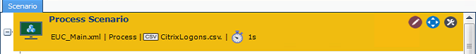

  - Domain – %user_domain% - Global variable.

- Citrix List Resources

  - Filter – This allows you to specify which published resource to launch. It can match part or the whole resource name.
  - %Citrix_Desktop_Name% Global variable is used here

  - Output Variable – A ScenarioBuilder variable to hold the name of the resource, which is passed to Citrix Launch Resource.

- Citrix Launch Resource

  - Citrix Resource Variable – use the same variable as specified in Output Variable above.

Initiation
The Initiation scenario is used to setup the user’s profile for the test. The scenario, as provided, performs two functions:

- Extract the Content.zip file to the user’s profile folder. This uses a Powershell command to extract the file.

NOTE: You must place the AutomaiKW.zip file in a central location that is accessible by all users. This should be a file share located close to the VDI environment. You will need to populate Global variable %Content_Zip% with the location of the zip file.

- The Loop within the scenario contains a CSV, this CSV holds the PowerShell commands used to configure application settings within the users testing environment.

Check App
The Check App scenario is a snippet, this scenario is passed a number of images as variables. The Scenario first checks the taskbar to see if the app is open, then it checks if it is on screen. It will manage the logic on whether to bring the app in focus or start a new instance. All apps are opened using powershell to ensure all open maximized.

Close App
The Close App scenario is a snippet, this scenario is passed a number of images as variables. The Scenario first checks the taskbar to see if the app is open, then it checks if it is on screen. It will manage the logic to bring the app into focus and then close it.

Browser_Base
The Browser_Base scenario opens all the different types of browsers. Using Check App, each type of browser is launched or bought into focus if already running. The scenario then clicks into the search bar and called the relevant scenario from a variable that is set in the EUC_Main script. Once the workload has run %CloseBrowser_OnEnd% is evaluated to see if the browser should be closed. If the Global variable %Reuse_Browser_Tab% is set to 0 the script will launch a new tab before calling the browser workload.

Outlook – New Email
The Outlook – New Email scenario opens Microsoft Outlook and creates a new email. The body of the email is text copied from a Random Text Generator. The email is discarded upon completion. A variable is configured to decide if Outlook will close on completion - %CloseOutlook_OnEnd% Global variable.

Email – Reply
The Email – Reply.XML scenario opens Outlook, selects one of the existing emails in the Inbox and writes a reply to the email using text copied from a Random Text Generator. The save button is pressed, placing the email into the Drafts folder. A variable is configured to decide if Outlook will close on completion - %CloseOutlook_OnEnd% Global variable.

Browser – Bouncing
The Browser – Bouncing scenario opens an HTML page through the run command. This leverages the browser configured using the %Browser_Choice% Global variable. The HTML page is located in the user’s Profile folder. It displays a bouncing ball screen.

Browser – Cyber
The Browser – Cyber scenario opens an HTML page through the run command. This leverages the browser configured using the %Browser_Choice% Global variable. The HTML page is located in the user’s Profile folder. It displays a template of a webpage dealing with Cyber-Technologies and clicks on some of the links.

Browser – Folio
The Browser – Folio scenario opens an HTML page through the run command. This leverages the browser configured using the %Browser_Choice% Global variable. The HTML page is located in the user’s Profile folder. It displays a template of a webpage meant for designers to display their folio. It has some animations. Some of the links are clicked by the scenario.

Browser – Video1
The Browser – Video1 scenario opens an HTML page through the run command. This leverages the browser configured using the %Browser_Choice% Global variable. The HTML page is located in the user’s Profile folder. It displays a 10 second animated video of a bunny.

Browser – Video 2
The Browser – Video 2.XML scenario opens an HTML page through the run command. This leverages the browser configured using the %Browser_Choice% Global variable. The HTML page is located in the user’s Profile folder. It displays a 22 second animated video of an elevated train.

MS Excel
The MS Excel scenario opens a XSLX file through the run command. The XLSX file is a sample file that contains a number of columns from a Sales report. After the file is open, a chart is created from a number of columns. The chart is then cut and pasted into a new worksheet and resized.

MS PowerPoint
The MS Powerpoint scenario opens Microsoft PowerPoint and creates a new presentation. This presentation has 3 slides and is displayed as a slideshow.

MS Word
The MS Word scenario opens Microsoft Word and creates a new blank document. It then types text copied from a Random Text Generator.

PDF

The PDF scenario opens a PDF file through the run command. This leverages the default application for PDF files for the user. The PDF file is located in the user’s profile folder and contains graphics and sample text. The scenario will scroll through the document before closing it out.

Logoff User

The Logoff User scenario will log the user off the Published Desktop. This should work for all Brokering platforms, as it uses the Windows Start icon to log off the user.

Prerequisites
The following points are requirements for that must be adhered to for the Scenarios to work correctly.
- If using a Citrix Environment
  - Desktops must be configured to launch fullscreen
  - https://support.citrix.com/article/CTX139762
- The run option in the startmenu must be available to users
- PowerShell much be able to be launched by users
- The AIChannel Share must be reachable from the worker machines and the bot manager

Supported and Tested Application Releases
Microsoft 365 Apps – 2210 (15726.20202)
Mozilla Firefox – 108.0.2
Microsoft Edge – 108.0.1462.76
Google Chrome – 108.0.5359.125

We recommend that you match these versions within your environment; older or newer versions may still work fine. We do our best to keep up with changes from software vendors.

